Twin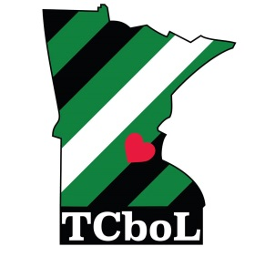 Cities

boys of Leather

Membership Application
Date:______________ Date of Birth:_______________
Legal Name:______________________________ Name to be called:_____________________________
Address:__________________________________ City, State, ZIP:______________________________________
Home Phone:___________________________ Cell Phone: _____________________________
Email:___________________________________________________________________________________________
What other clubs or organizations do you belong to?_____________________________________________________
________________________________________________________________________________________________
How did you hear of Twin Cities boys of Leather?________________________________________________________
List one reference we may verify within the leather community (or club sponsorship if none):
Name:______________________________________ Phone or Email:______________________________________
For the following questions please answer fully and to the best of your ability. Feel free to add additional pages if you need more room.
Why are you interested in joining the Twin Cities boys of Leather?

What do you expect to get out of membership in Twin Cities boys of Leather?

Have you been to any of our events yet? If so, which ones and what did you enjoy about them?

jkljklj

Would you like to participate in volunteer service activities with Twin Cities boys of Leather? Yes No
If Yes, please list any special skills, background, etc. you have with volunteer service:

I hereby submit this application for consideration by Twin Cities boys of Leather. I understand any information gathered is held confidential and will not be shared with anyone without my consent. I hereby also agree to comply with the bylaws, rules, and regulations of the organization, and to hold myself to the behavioral and ethical standards of the Twin Cities boys of Leather and at all Twin Cities boys of Leather events and while wearing Twin Cities boys of Leather colors. I further agree to hold harmless the Twin Cities boys of Leather, its officers, members, representatives, advisors, and associate or sponsor businesses for any injury or loss to myself or property which may occur during my participation in any Twin Cities boys of Leather event, and to obey all local, state and federal laws while participating in Twin Cities boys of Leather events.

Applicant Signature:_____________________________________________ Date:______________________

